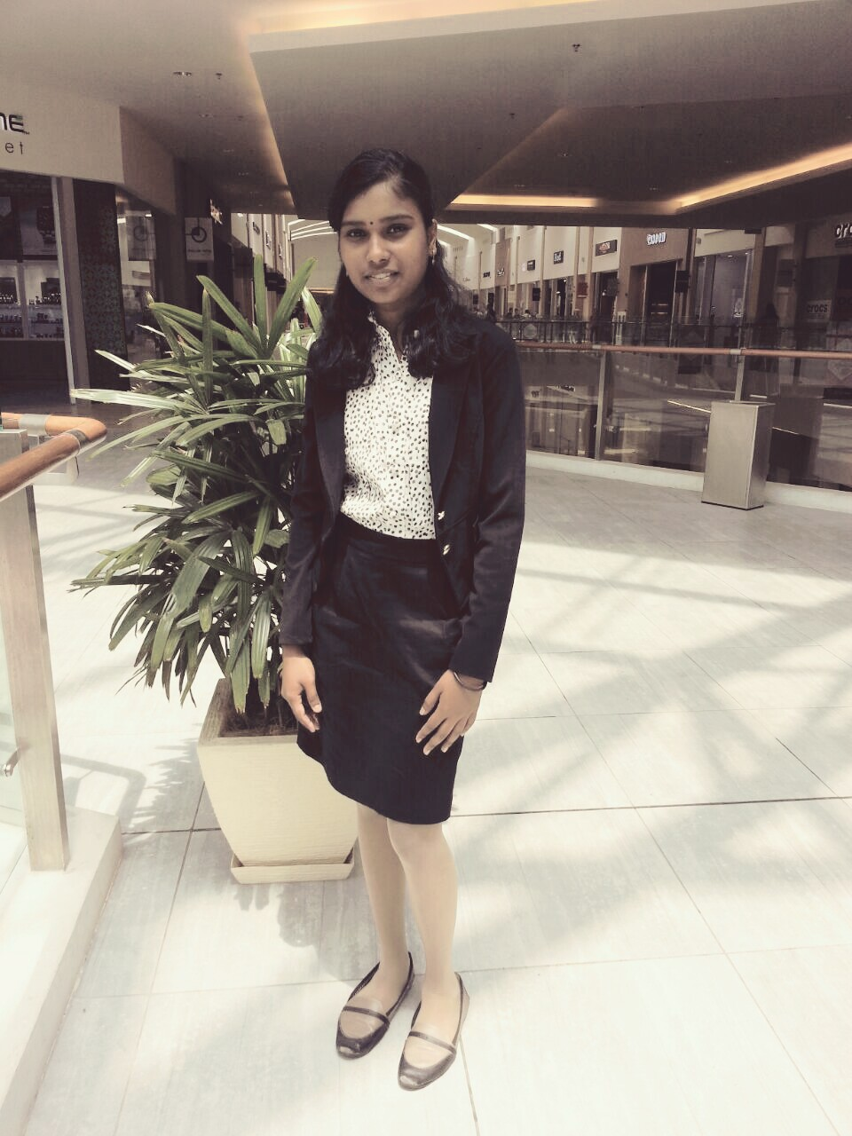

KHOGILA A/P PANNI SELVAM

Contact No: (010-9317988) Email: [khogila96@gmail.com](mailto:khogila96@gmail.com)

IC No : 961022-05-5022) Address : (PT 775, Jalan, Teratai 1, Taman Jimah Indah Tanah Merah, Site “A” 43900 Sepang. Selangor)

**DIPLOMA IN TELECOMUNICATION TECHONOLOGY**

Ampang Community College

2018

|  |  |  |
| --- | --- | --- |
|  | Education |  |
|  |  |
| **SIJIL PELAJARAN MALAYSIA**  SMK Sungai Pelek  2013  **CERTIFICATE IN**  **COMPUTER SYSTEM**  Jelebu Community College  2015 | | |

|  |  |  |
| --- | --- | --- |
|  | Work Experience |  |
|  |  |

**Industrial training at Asian Aviation Center of Excellence Sdn Bhd as**

**Junior Admin for Content Development Department from July 2016 to November 2016.**

**Preparing and editing the entire training syllabus into slides including exams as below:-**

* **A320 and A330 pilot training syllabus.**
* **Cabin crew training slides**
* **Guest service training slides**
* **Ground operation slides**
* **Ramp and engineering slides**
* **Exam slides for all the aviation training**

|  |  |  |
| --- | --- | --- |
|  | **AWARDS** |  |
|  |  |

* Short Video Competition (Gold Medal)
* Merdeka Day Wefie Competition 2017 (Gold Medal)
* Community College Innovation Competition (Bronze Medal)
* Directors' ‘s Awards for first semester (CGPA 3.73)

|  |  |  |
| --- | --- | --- |
|  | Key Skills |  |
|  |  |

**COMPETENT IN:**

* Mobile device repairing
* Apps developer
* Software programming

**LANGUAGE:**

|  |  |  |
| --- | --- | --- |
| Bahasa Malaysia | 10/10 | 9/10 |
| English | 9/10 | 8/10 |
| Tamil | 10/10 | 10/10 |

**COMPUTER SKILLS:**

* Microsoft office
* Adobe Photoshop
* Adobe illustrator
* Software installation

|  |  |  |
| --- | --- | --- |
|  | Reference |  |
|  |  |

**En. Mohd Faisal Bin Ishak**

Principal Lecturer

Ampang Community College

Tel : 03-42800201

H/p : 012-6260202

Email : [mfi.kkas@gmail.com](mailto:mfi.kkas@gmail.com)

Pn. Siti Rafidah Binti Abdul Saref

Ampang Community College

H/P : 012-2499657

Email : Siti.rafidah@kkampang.edu.my